­

ITEC 1100

Interactive Multimedia Design

Assignment 4

Dina Egorov

101236253

**Game Design**

1. CONCEPT

In this single-player game called *Lights Out*, the main character is one young and curious fifteen year old boy named Juco. Juco is a citizen of Yensville, a small city of planet D68 that humans have fled to after Earth’s complete climate destruction. A few years ago, skeletons named Reus visited the planet and decided to remain there in fascination with its warm climate. The Reus have been treated inferiorly by the kingdom, with the royal family suggesting they leave the planet. Considering the mistreatment, the Reus have taken over the land after kidnapping the royal family and keeping them imprisoned. The leader Reu sits on the throne advising on any issues, basking in the royal environment while the citizens are forced to work for them. The rest of the Reus roam the streets and the land of Yensville, thus granting them their names after the french word “rue”, meaning road. In the daytime, adult citizens go to their assigned posts to work on farming, technology creation, tailoring, or other services. Children up until the age of sixteen are seen as useless, so they are allowed to do whatever they please all day. At night, all citizens are required to stay inside their homes from sunset to sunrise otherwise they would never be seen again. There are multiple rumours to what happens to the disappearances, one being that the Reus eat the human alive facilitated by the sharpness of their visible bones. For this reason, no one defies the Reus and rests obedient out of fear of their lives. The goal of this game is to reach the royal castle in the darkness of night, and destroy the energy crystal that is binded onto the leader’s staff. Without the crystal, the Reus will not survive and they will disintegrate into ash. Since the Reus can only see in light, the main character attempts to travel through the 2D streets and forests with a computer keyboard’s arrow keys while avoiding the circular light coming from the Reus’ lamps. Like all humans, the main character only has one life, resulting in a restart of the realm if caught by the Reus. The main character starts at the outskirts of the city and sneaks past Reus farther into the core of the kingdom, where the population of Reus increases. When the main character reaches the castle, the only goal is to reach the sleeping leader surrounded by security, while finding the corresponding keys and doors as they explore the castle to shatter the crystal. The world includes roads made of cobblestone, skies filled with supernovas, and surrounding forests filled with ninety-foot trees. As the main character travels from realm to realm, they meet other young adolescents with similar values--they dislike the current political situation and wish to get rid of the totalitarian regime.

1. CHARACTER DESIGN

Main character: Juco

Juco is the protagonist in this game. He is a teenage boy of an average household. He has a soft spot for his family, who he rarely sees because of their duties in the assigned work places. He was a timid boy in school, until the Reus took over and continuously exercised his willpower to become bold and rebellious. He is easily distinguishable by his platinum white hair. Juco is quick on his feet, and has great reflexes. He is motivated to extinguish the Reus because of his friends who had gone missing, presumably at the hands of the Reus. Juco usually carries a crossbody bag. This accessory is used to fit an endless amount of peppermint patties, which is his comfort food when the atmosphere becomes tense. He does not like being alone, and feels relieved to meet friends who share the same views along his journey through the city.

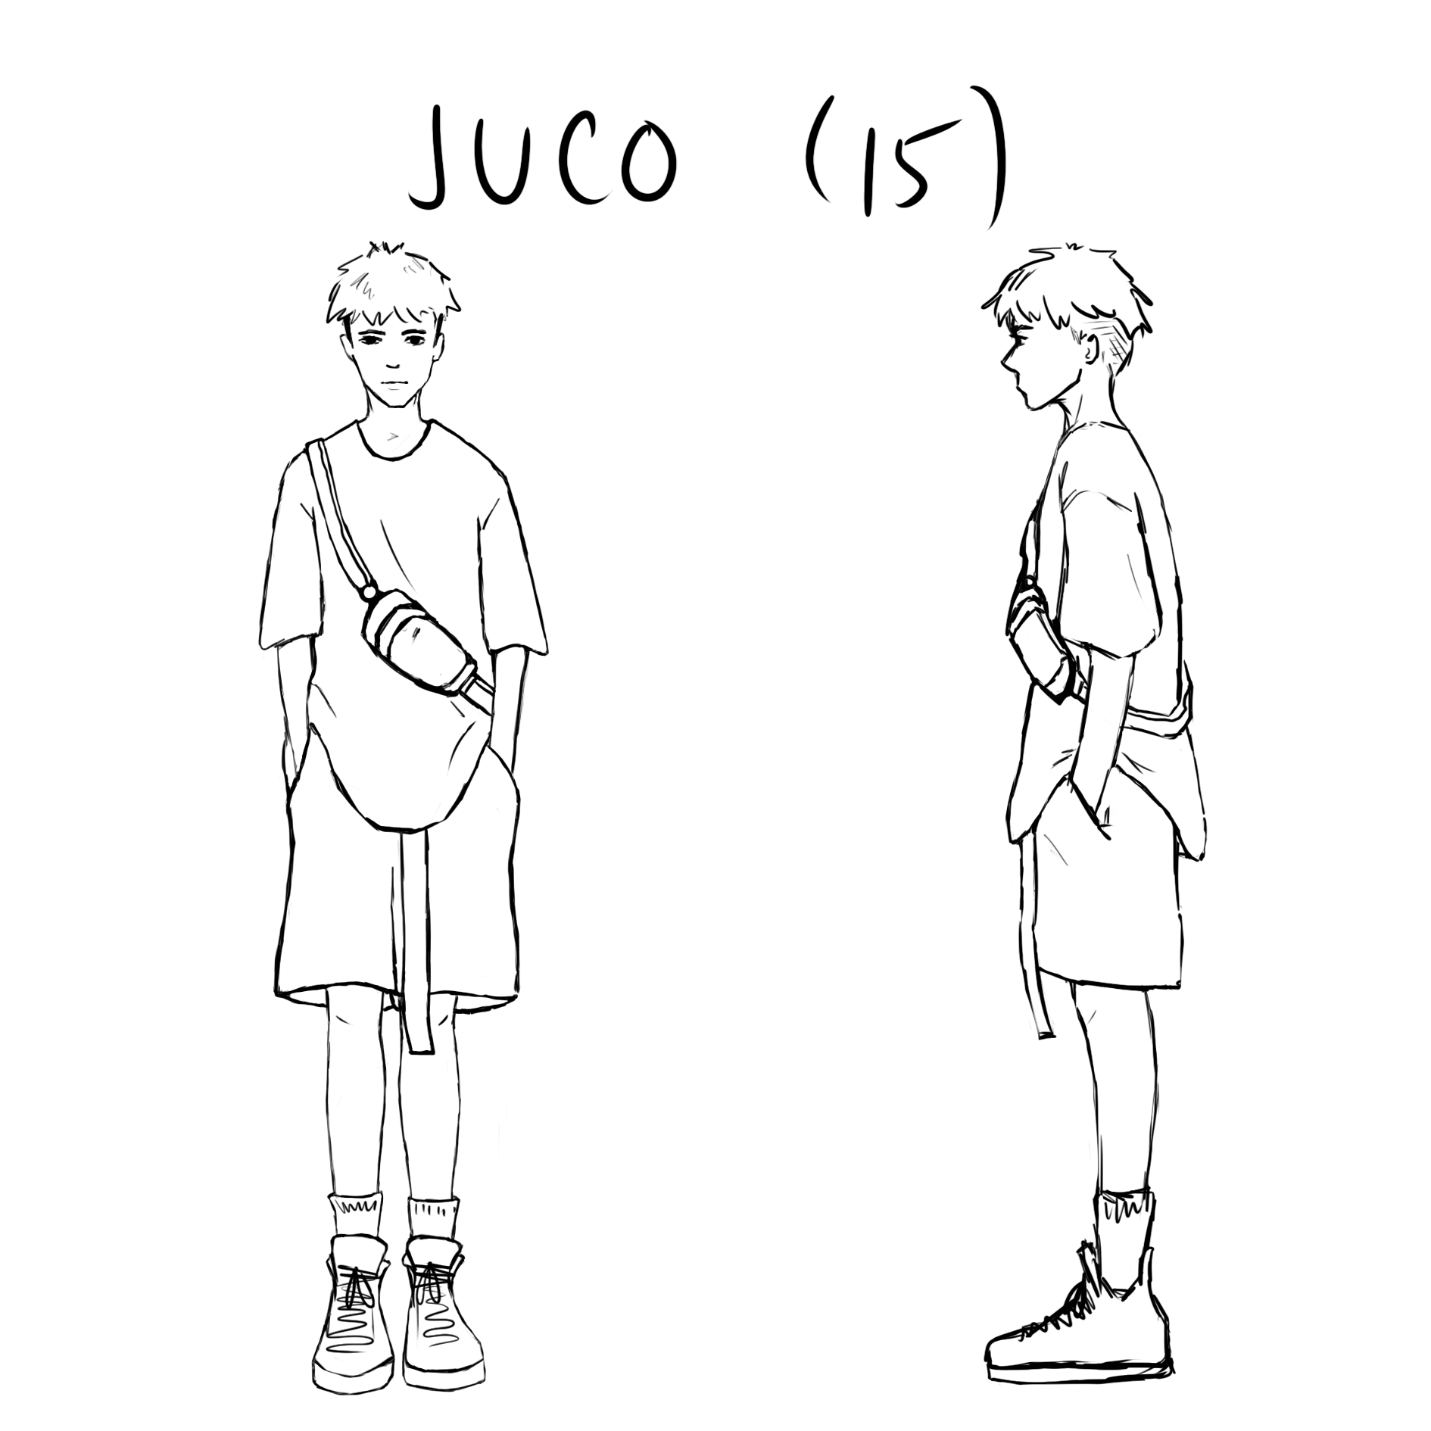

A Reu (all Reus look similar):

Reus have skeletal bodies covered by a cloak, often to keep them warm (thus explaining their love for this planet). They have thin slits for eyes which consist of only the pupil. They have no lower jaw bone, their tongue tucked into the roof of their mouths. Horns protrude from the tops of their heads, made of skull bone and soft tissues. These are the most sensitive parts of the Reus that are easily accessible and easily harmed. The leader Reu has the biggest and thickest horns. They are indifferent most of the time, obeying orders and being duteous. They are seven feet tall, towering over Yensville citizens. They have great memory, remembering faces or features of animals, humans, or objects only after a glimpse. When moving, they are fast because of the slenderness and length of their bodies.

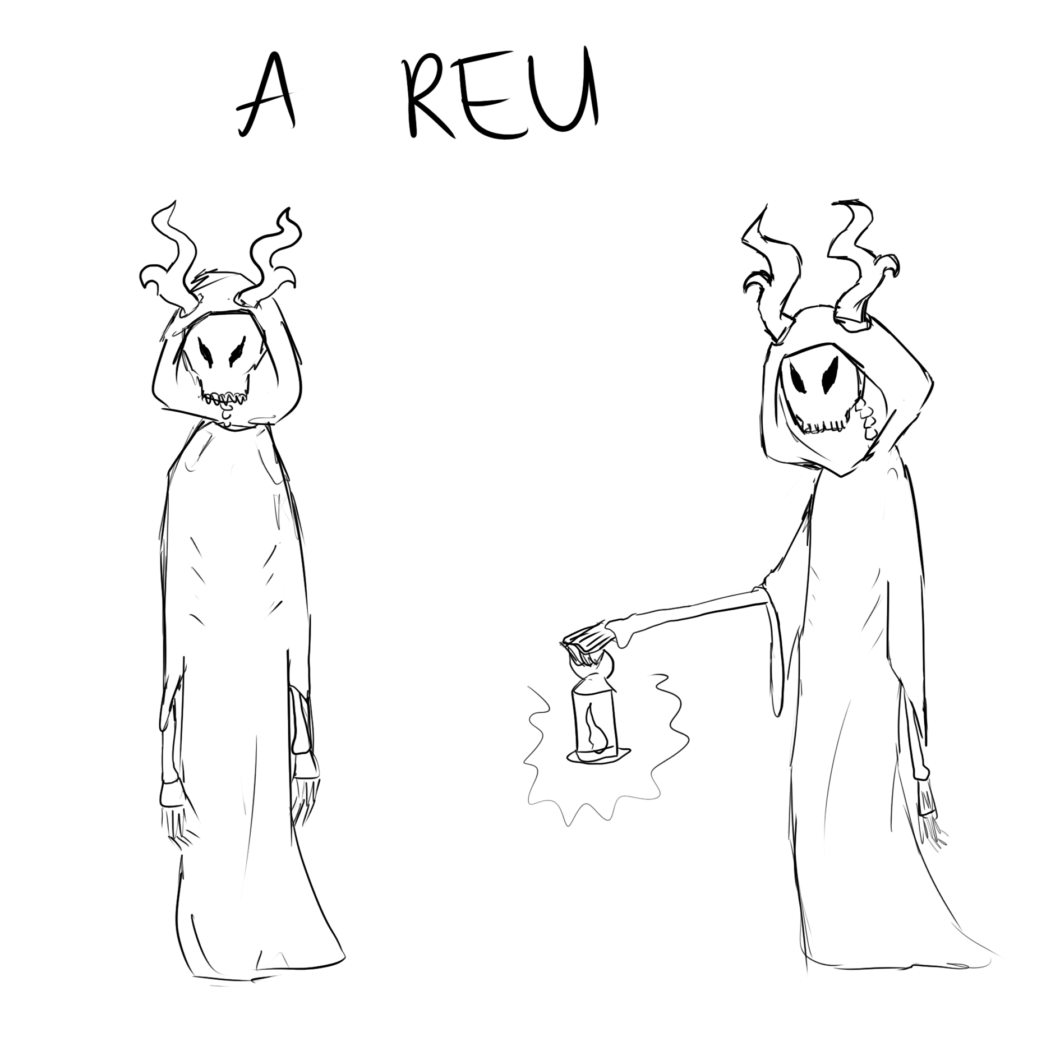

Step Documentary:

When creating the main character, I thought of what features would attract players and how relatable they would be. To young players, the Reus are more likely to catch their attention because of their supernatural design. To teenagers and young adults, the main character, as well as the other collectable skins, are attractive because of the relatability in age and visual interest. I wanted to create a visually pleasing character so audience members are able to create a sort of emotional attachment, which would be shared among the other skins available to them. Young players are influenced the easiest, so providing visuals like this could encourage them to spread the word about the game to their friends by expressing their fascination with any character. Finally, I included platinum white hair for modernization, and peppermint patties to have my own little connection with the game, since I love mint and chocolate. I had originally planned for the Reus to have longer arms and to not include the cloak, but sometimes mystery is appealing and invites lore. The body was tricky to design, since I could only fully visualize the head. I tried sketching various designs: without the cloak, with fleshed legs, and a tail. I figured this would be extremely difficult to animate as they walk in the game, and would look rather awkward than ominous. Since the Reus dominate, I gave them an obvious weakness such as their horns. Even though they are out in the open, the lack of rebellion from humans shows their feelings of intimidation.

1. ENVIRONMENT DESIGN

Moodboard

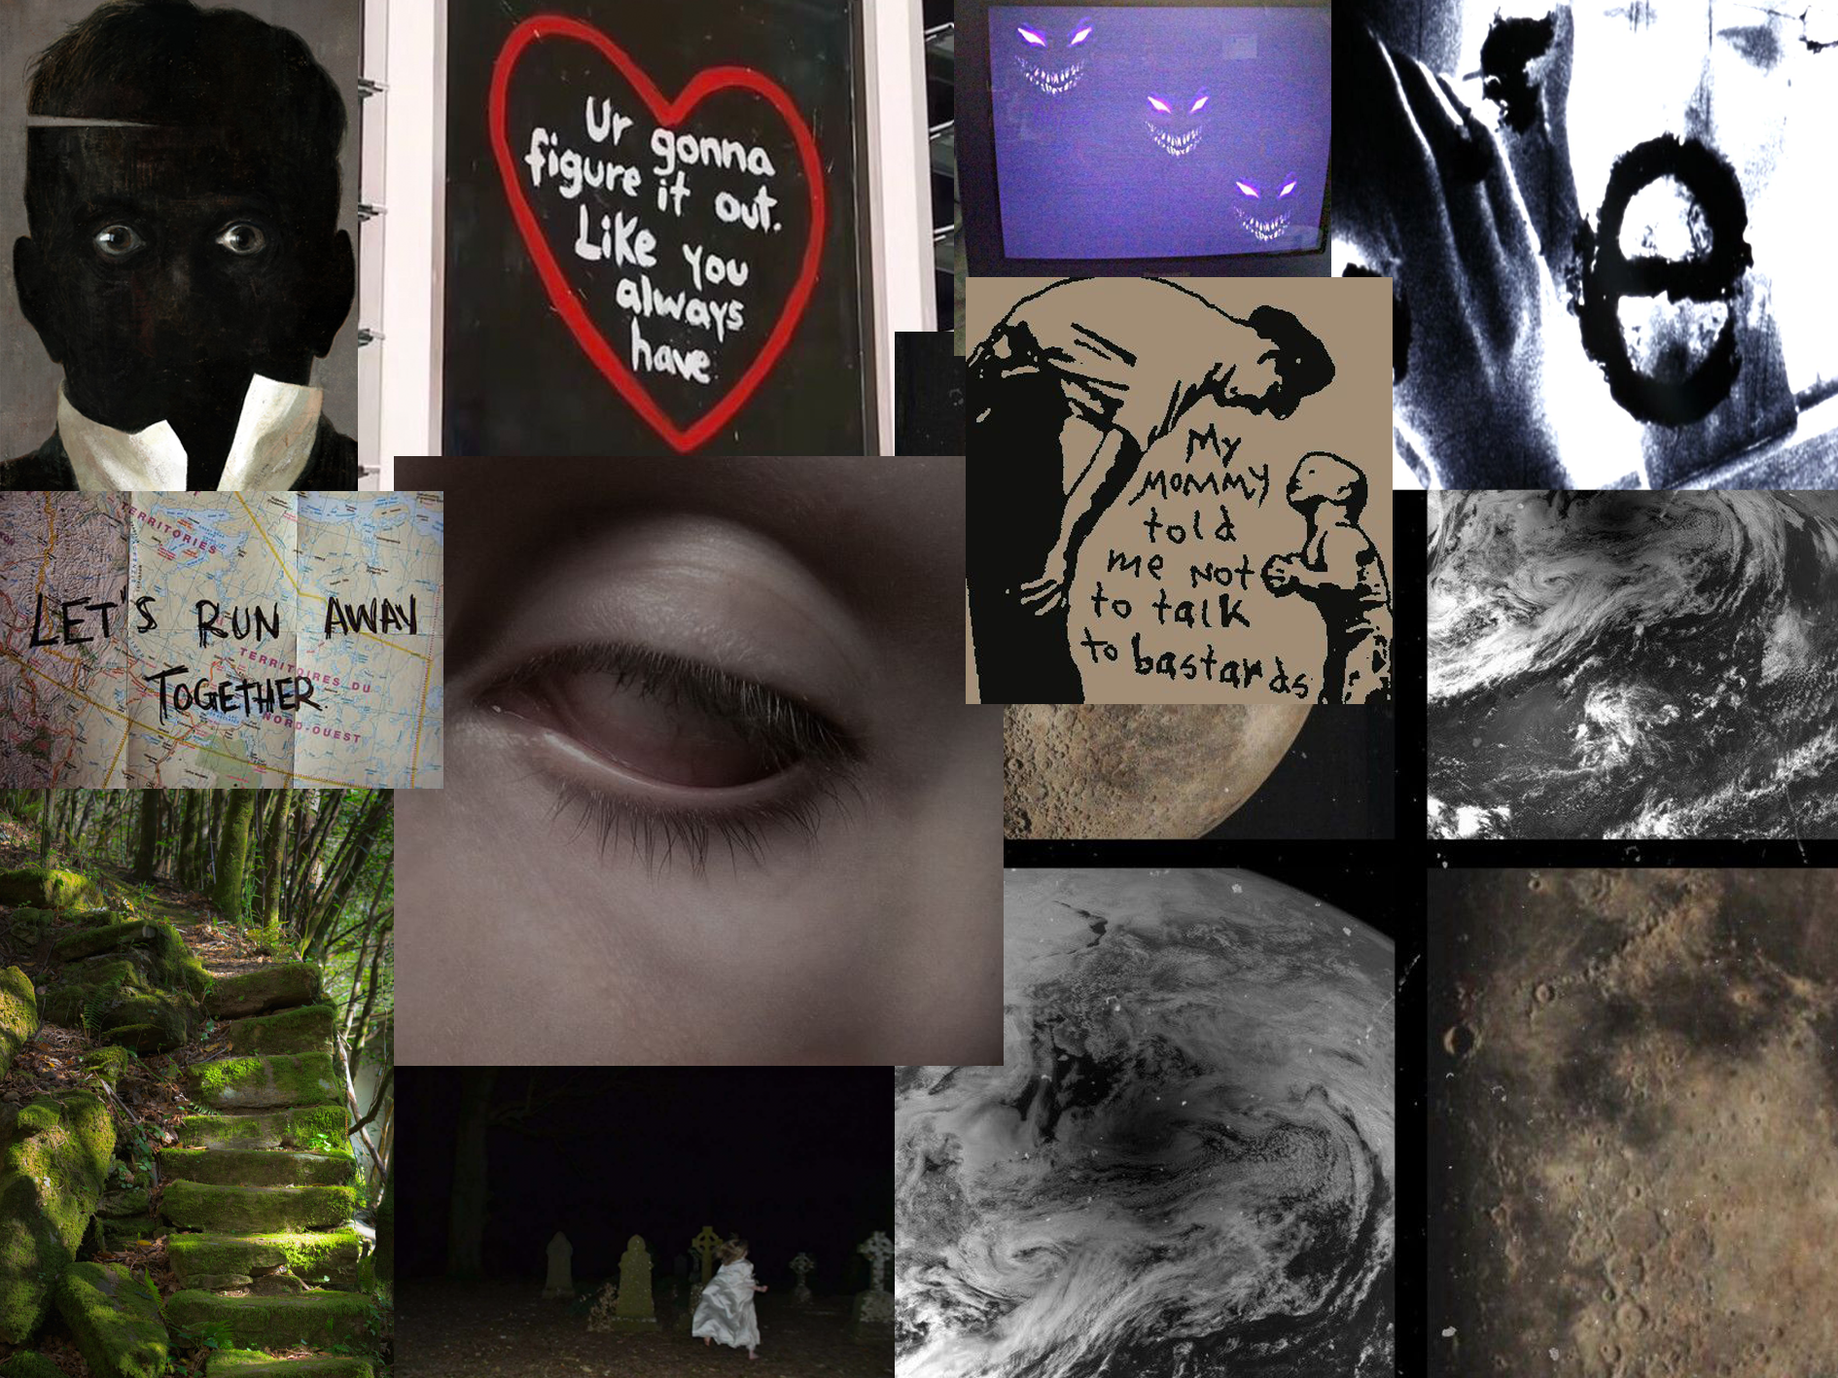

World Sketch

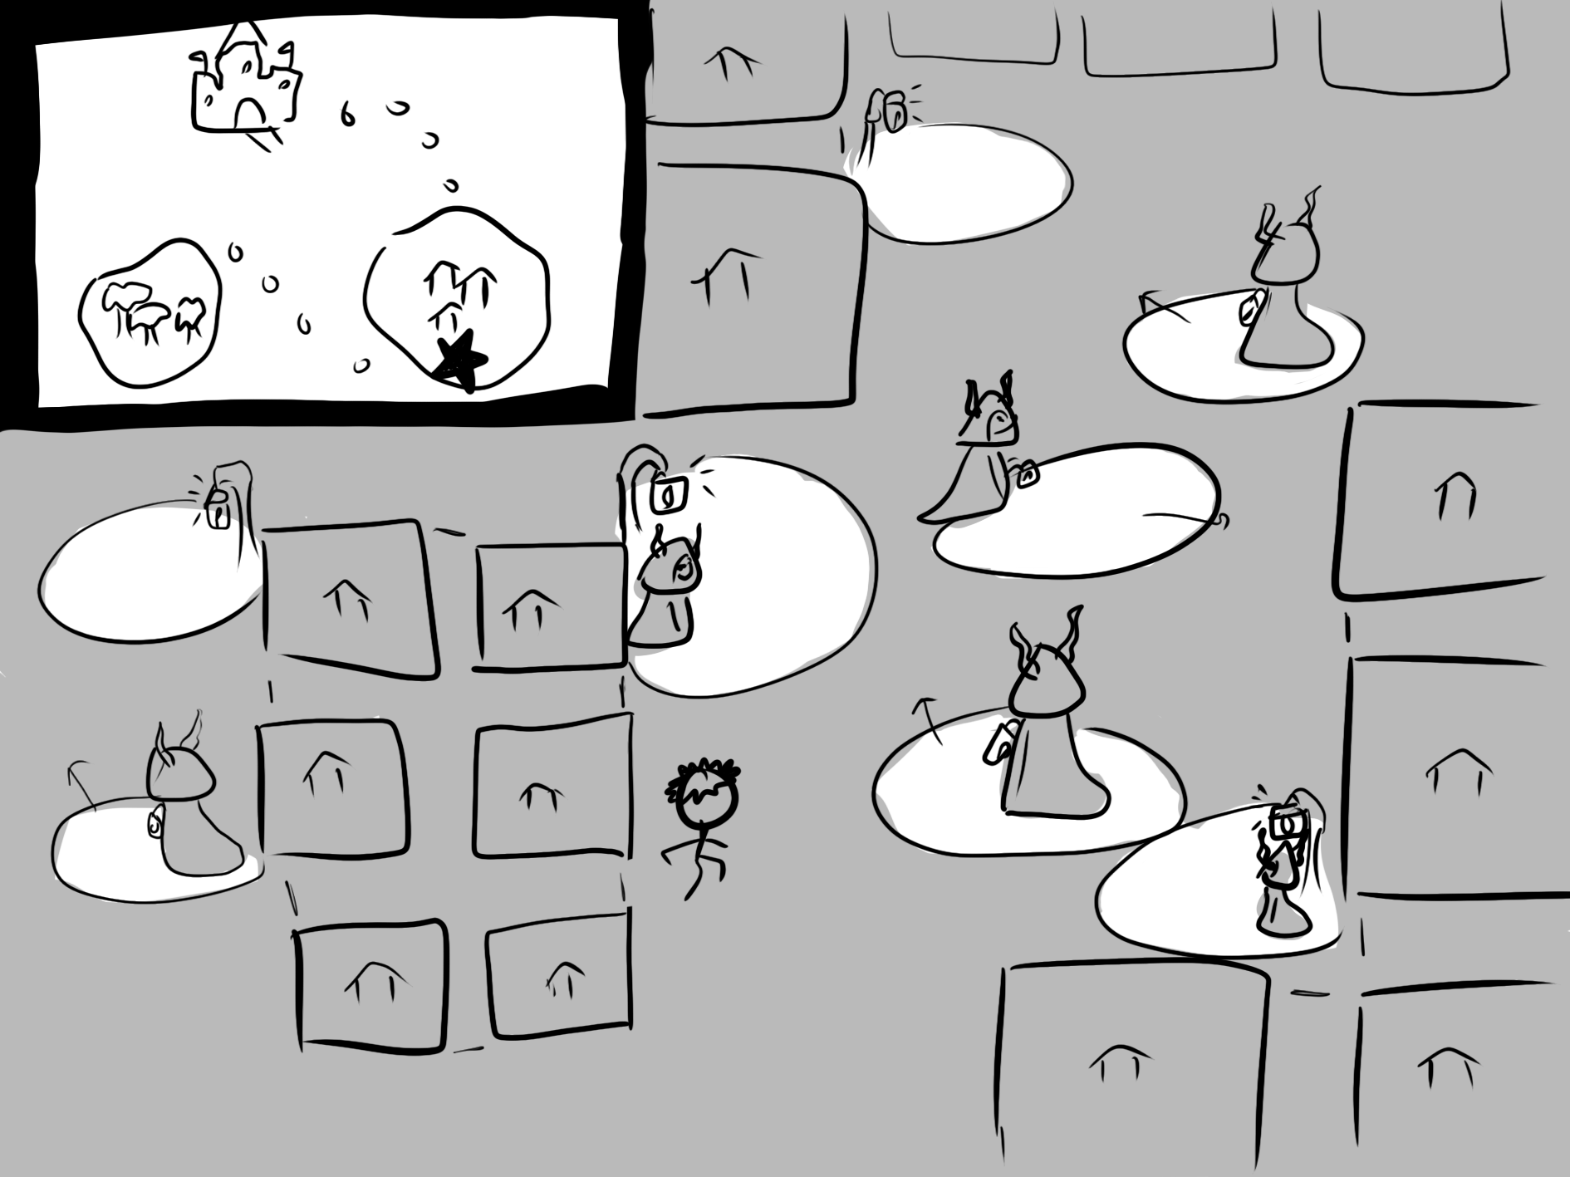

1. MACHINERY PUZZLE

The main concept of the game is to avoid the light coming from lampposts and the lamps that the Reus carry. By doing so, players use the arrow keys to move strategically in bounded areas. The player has unlimited movement through the streets, the camera moving while centered on the character. The Reus follow predetermined paths to roam, which can be observed and memorized with time. Each level has a different path that players are required to cross, with the difficulty increasing as they get closer to the castle. A few pathways through the kingdom are filled with Reus, making it impossible for characters to cross without being seen. So, players are required to play an additional puzzle. This puzzle includes the peppermint patties that Juco carries around with him at all times. In this puzzle, players exercise their aiming ability and intuition. Using the computer trackpad or a mouse, the player aims at targets. These targets are lamps or light switches that enable the Reus to see. By hitting a lamp with the spacebar after aiming, the fire is extinguished, and by hitting a light switch, the lights are turned off. Lamps are usually seen in the city streets on the way to the castle. Light switches are exclusively inside of the castle. At each crossing with a puzzle, there are three lights to be hit. The difficulty starts off as easy, with the target being relatively close. As the game progresses and players reach further into the kingdom, the difficulty increases. Lamps become far and when players reach inside of the castle, they have to watch out for weather circumstances such as the wind that will affect the projection of the thrown object. Since the castle is indoors, one window will have been broken from a fallen tree which will let wind pass through. Each puzzle has six attempts total--two attempts per lamp--to allow players to get a grasp of the direction. After each one of the aiming puzzles, the player meets another young character in the shadows that shares the same values with Juco. The player will then view the backstory of the character as they retell it to Juco through a cutscene. After the cutscene, the player is able to use the friend as a character skin. When other characters are picked for different skins, they also have personal items that can be thrown instead of the peppermints. Each level is continuously timed. There is a leaderboard for each level if players wish to join the challenge of achieving the fastest completion rate. The players complete the game after reaching the castle with the leader Reu sleeping on the throne. The final step is to aim and hit the crystal that sits on the leader’s staff. After this is done, a cutscene plays of the Reus dissolving, and citizens peeking out of their houses to view the phenomenon. Players are able to replay the game once completed.

**References**

*Celui qui tua Dieu in 2021: Words, Mood Pics, grunge aesthetic. Pinterest. (n.d.). Retrieved November 22, 2021, from https://www.pinterest.ca/pin/771804454898231243/.*

*Frankenstein*. Communication Arts. (n.d.). Retrieved November 19, 2021, from https://www.commarts.com/project/26218/frankenstein.

*Fresh poison: Stranger things aesthetic, dark aesthetic, eyes. Pinterest. (2021, August 7). Retrieved November 22, 2021, from https://www.pinterest.ca/pin/73535406406092290/.*

*Pin by 1 on ‎anything I think is cool in 2021: Ethereal art, Aesthetic Pictures, Goth Baby*. Pinterest. (2021, November 10). Retrieved November 19, 2021, from https://www.pinterest.ca/pin/626352260684312945/.

*Pin by venusimages.jpg on C: Purple aesthetic, aesthetic grunge, grunge aesthetic*. Pinterest. (2021, November 14). Retrieved November 22, 2021, from https://www.pinterest.ca/pin/30821578685606555/.

*See my soul: Creepy images, Southern Gothic, grunge aesthetic. Pinterest. (2021, November 21). Retrieved November 22, 2021, from https://www.pinterest.ca/pin/914862414728734/.*

*Sweet dreams are made of this: Pretty words, quotes, words*. Pinterest. (2021, November 18). Retrieved November 22, 2021, from https://www.pinterest.ca/pin/624874517056518428/.

*Ur gonna figure it out. like you always have. in 2021: Happy words, pretty words, cute quotes*. Pinterest. (n.d.). Retrieved November 22, 2021, from https://www.pinterest.ca/pin/262475484524151389/.

Wowtastic-Nature. (2015, May 24). *Wowtastic-Nature*. Artistic-realistic nature. Retrieved November 19, 2021, from https://wowtastic-nature.tumblr.com/post/119721607140/mystic-ancient-path-by-juan-antonio-valino.

*Фотопленка забитая чувствами: VK: рисунки углем, Абстрактное, стрит-арт*. Pinterest. (2021, November 8). Retrieved November 22, 2021, from https://www.pinterest.ca/pin/173177548162606092/.